W300M-How to configure the Client+AP Mode?
Product line: Wireless Question category: Function configurations

Q: When we need to configure the W300M as Client +AP Mode?
A: Sometimes the wireless signal is too weak or the wireless router is far away from the wireless client. You can choose Client + AP Mode for W300M to extend the wireless coverage.

Common network connection topology is as follows.
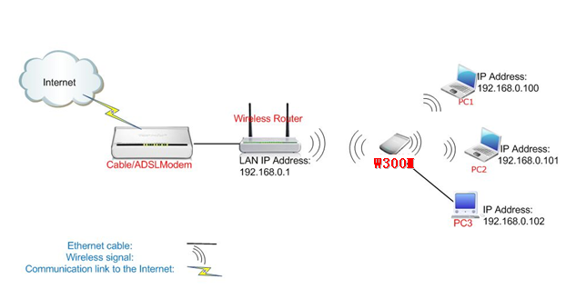
Steps are as follows:
- Connect the computer to the W300M with Ethernet cable.
- Login to the management page of the W300M. (the login IP is default to be 192.168.2.1, the username and password are both admin).
- In the management page, choose the default mode Client
+ AP->Setup Wizard. In the set up Wizard page, click Next.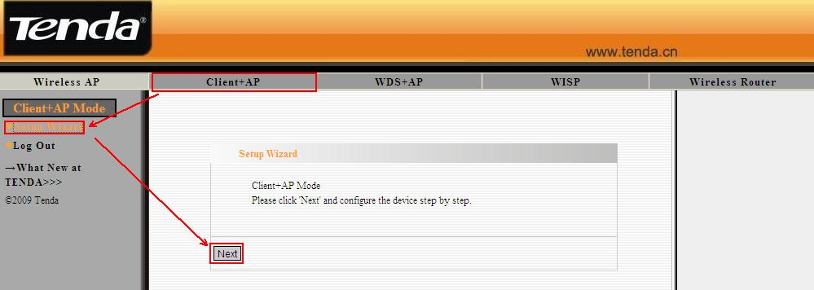

- In the Client Setup page. Click Scan to find the signal of the
uplink wireless router and choose it. Then you will need to configure the security parameters manually (Note: the Channel, Security Mode, Algorithms and password in the Pass phrase must be the same with uplink wireless router). Click Next.
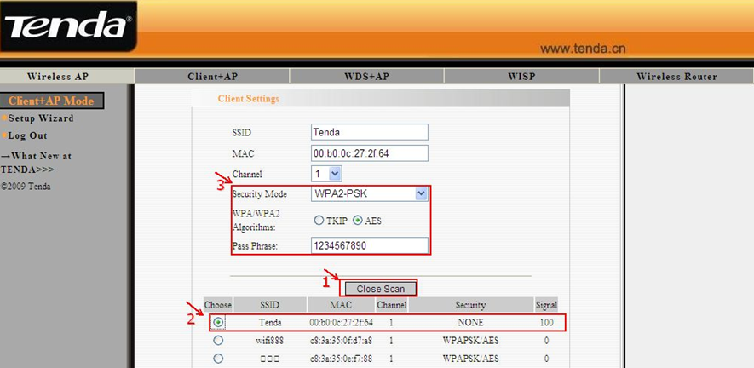5, In the Wireless Basic Setting page, you can do the basic configuration for your W150M. You can change the name of your W150M by changing the SSID and choose wireless Channel (the same with uplink wireless router) for your W150M. Click Next. 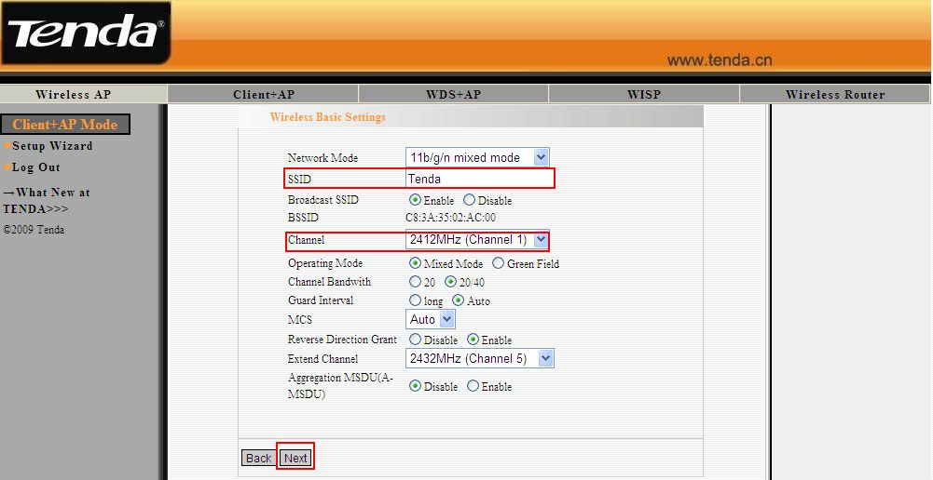
6, In the Wireless Security Settings page, please choose WPA-Personal as Security Mode and choose AES as WPA Algorithms. And type password for wireless network in the blank of Pass Phrase. Click Next. 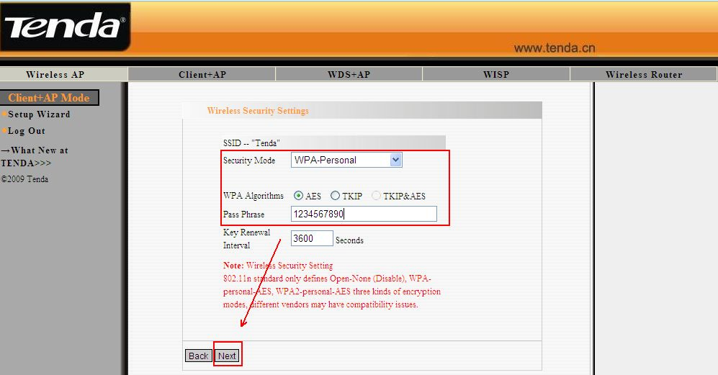
7, Click Apply to save the settings.
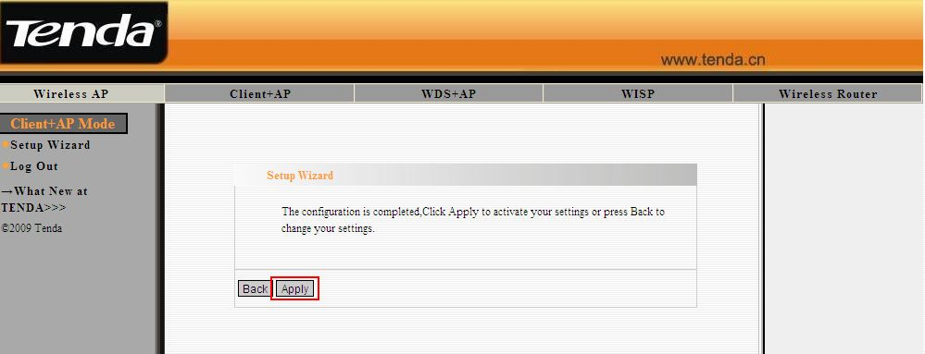
8, After the configuration, the W300M is connected to the uplink wireless router, the wireless clients connect to the W300M will get the ip address from uplink wireless router and connect to the internet normally.

